In this assignment we need to complete the camera calibration toolbox in matlab which made bu Caltech University based on total of 20 images of planar checkerboard. Out objective is to calculation parameters of camera calibration and optimizing them based on errors including distortions etc. Firstly, we need to read all images. In my implementation there are 20 + 5 images with bmp extention which shotted by me. Below you find all 20+5 image in a mosaic form. Also, all images are attached in the zip file.

Extract the grid corners:

The first things we need to do, is the extracting the grid corners. To achieve that we have to arrange wintx and winty values. It is selected by default 5 and we have enabled automatic square counting. First 20 image is included. Then we selected four corner in order for each image to calculate external and internal parameters. For some image, the real-worlds corners and calculated corners is not overlapped. Therefore we have to took into account the distortion coefficient. We need to arrange the distortion by estimating distortion coefficient for maximum correctness until we satisfied. Please check the processes of this extracted grid corners. We did the same thing for rest of the images and obtain calib_data.mat file which is attached in the zip file.
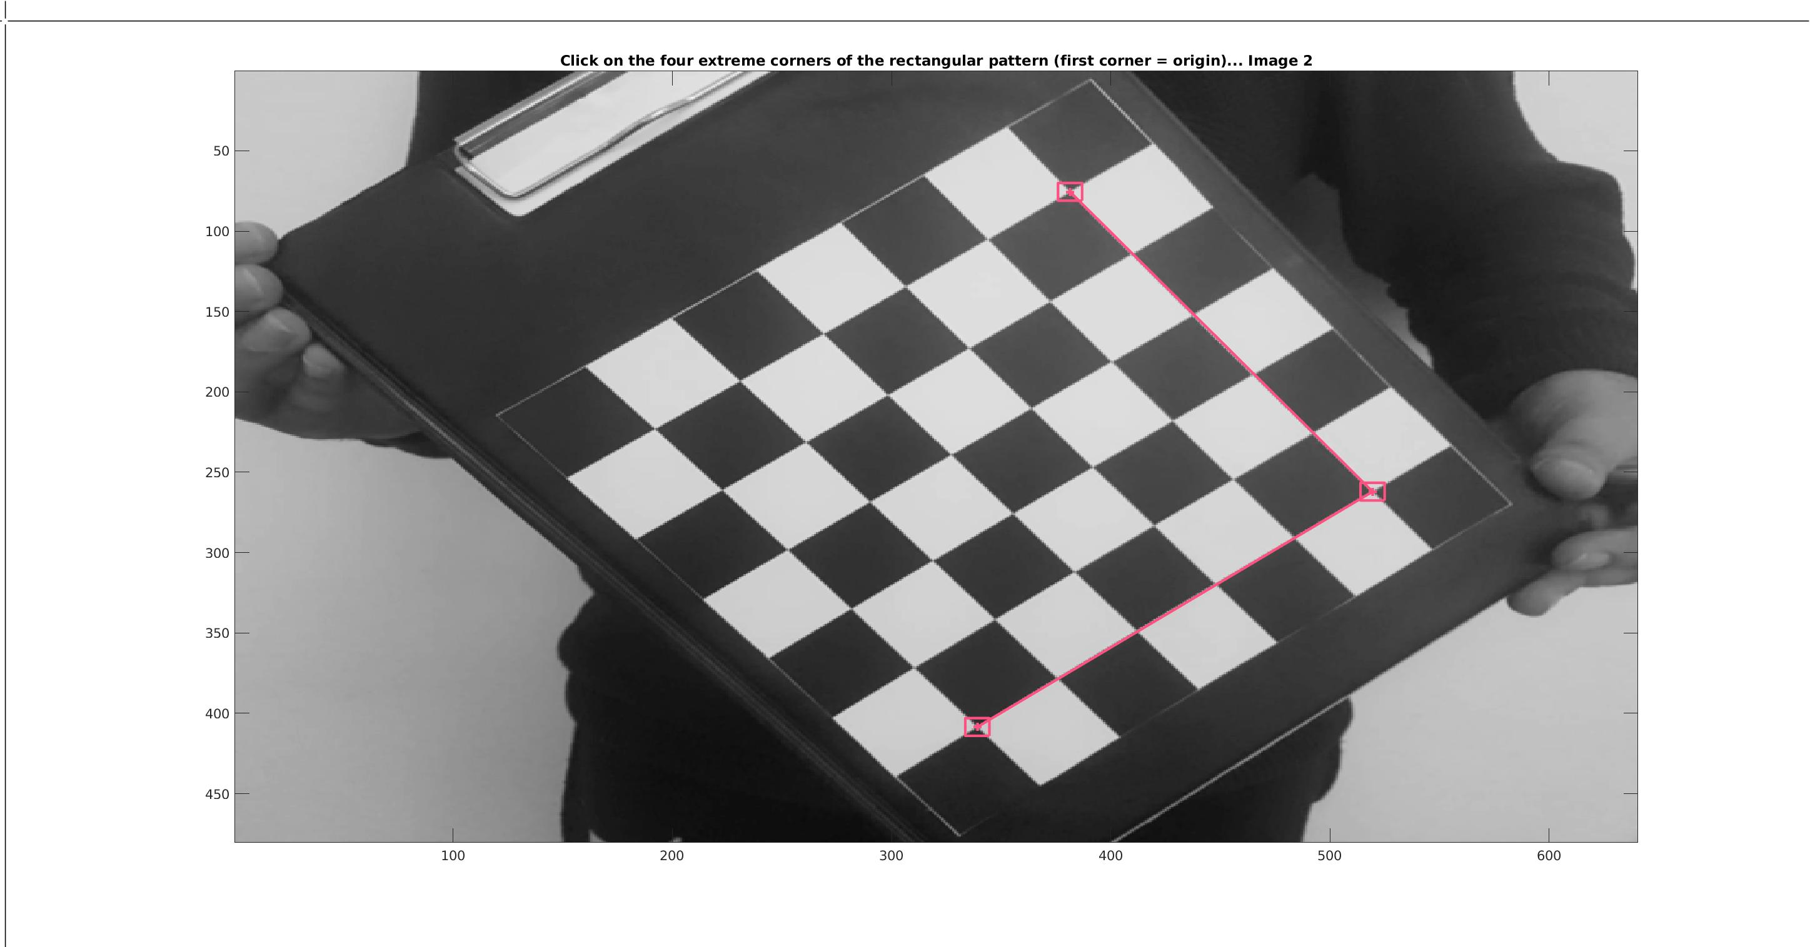
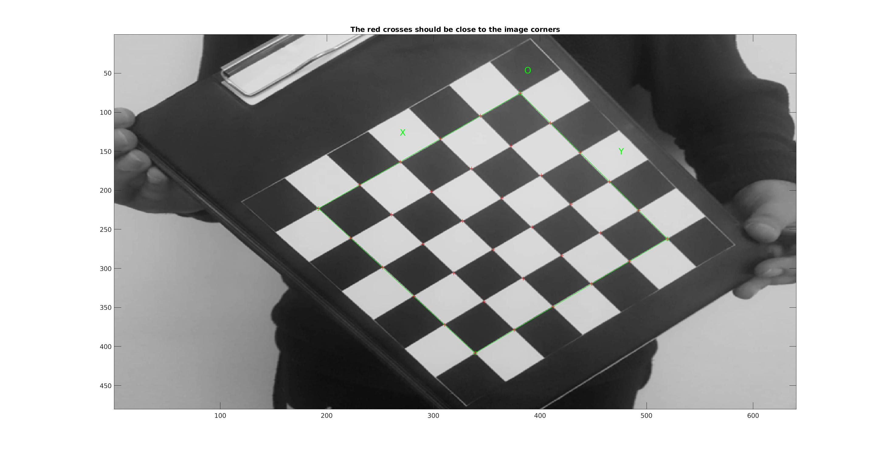

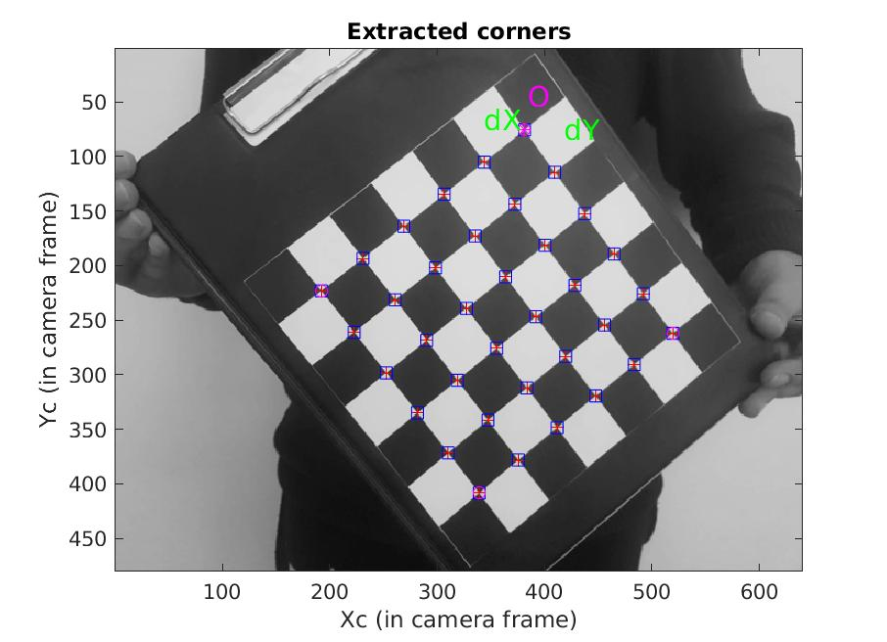
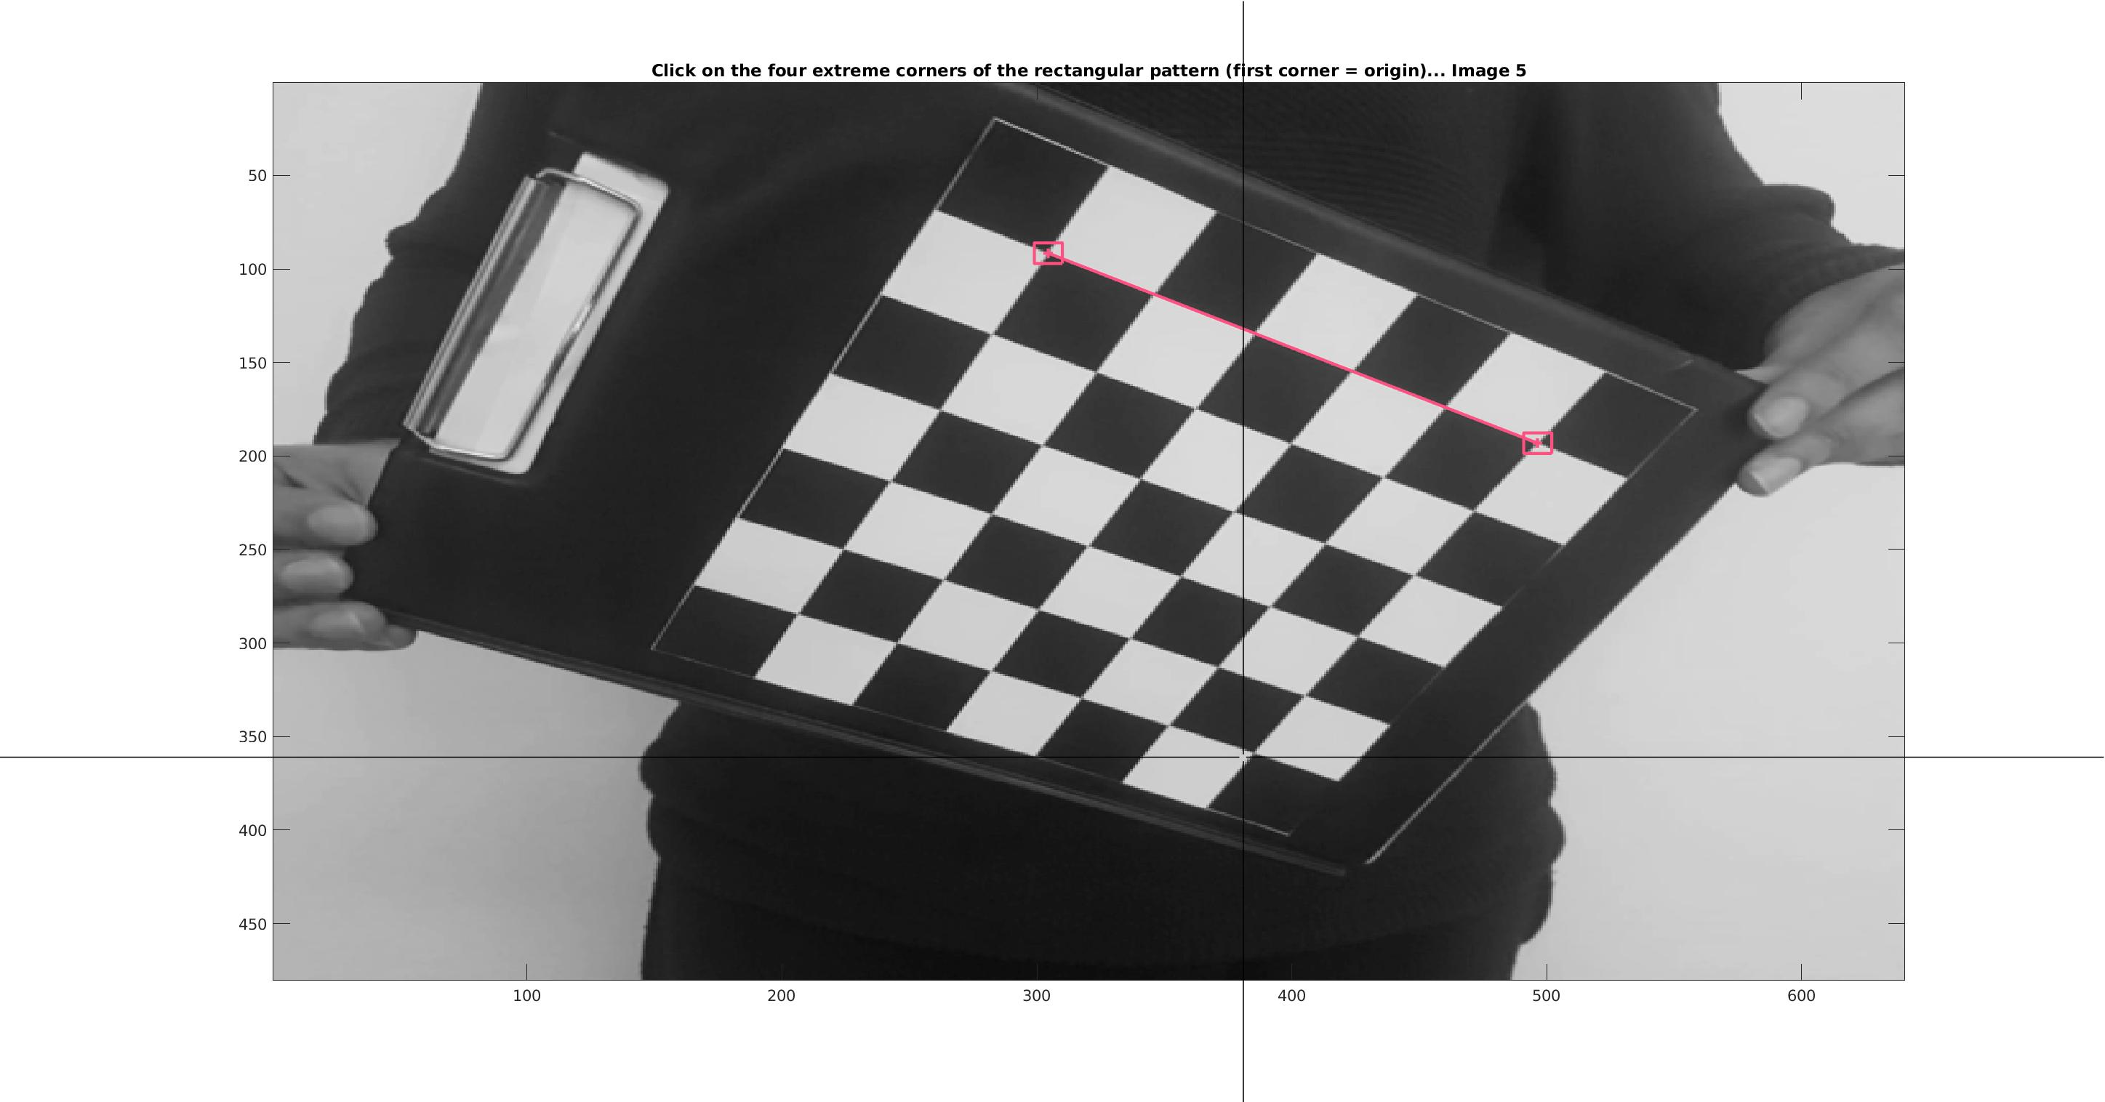

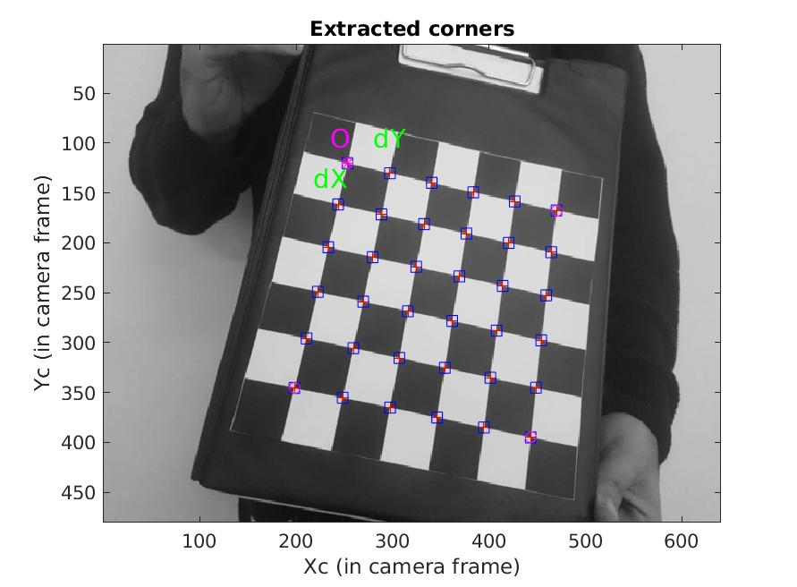

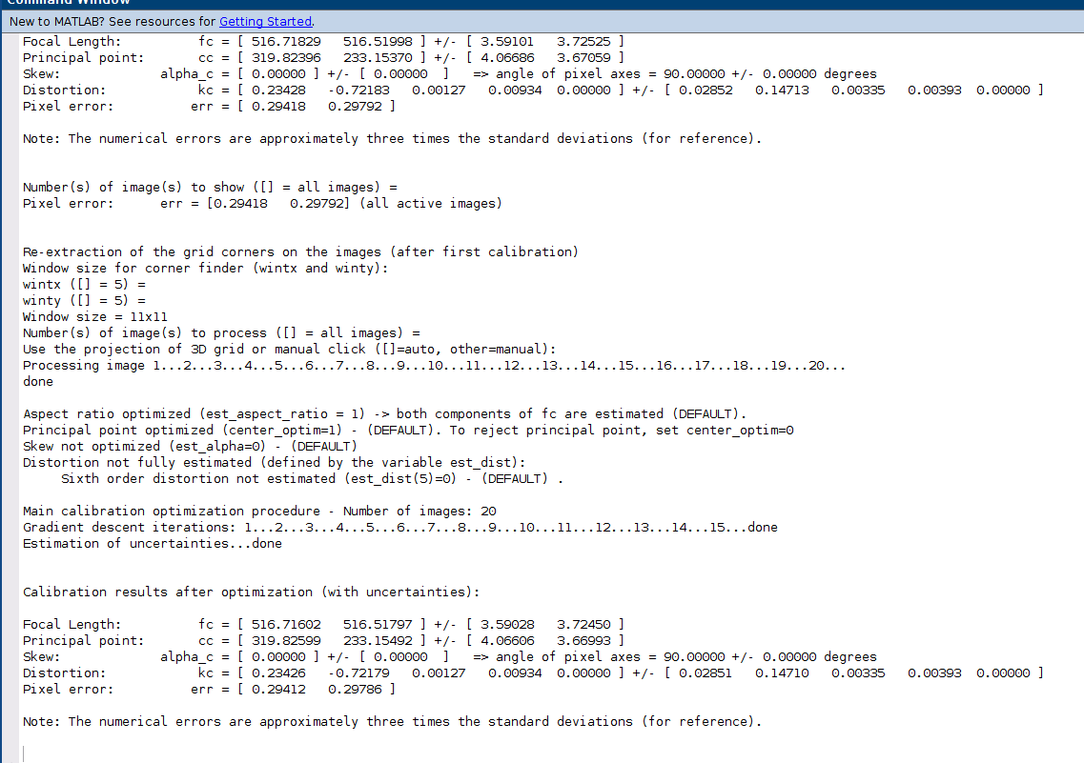
After the corner extraction, we activated the main calibration process. There is two main process in this calibration step; first initialization and non-linear optimization. Initialization step computes the closed-form solution for external and internal parameters of calibration. The non-linear optimization minimized the total least square projection error. There are 129 parameters overall (9 for instructions and 6*20 for extrinsic). Below, the calibration parameters is given.

Then, we reproject the calibration parameters on the previous images. Below, there are 3 sample image which are grid re projected.
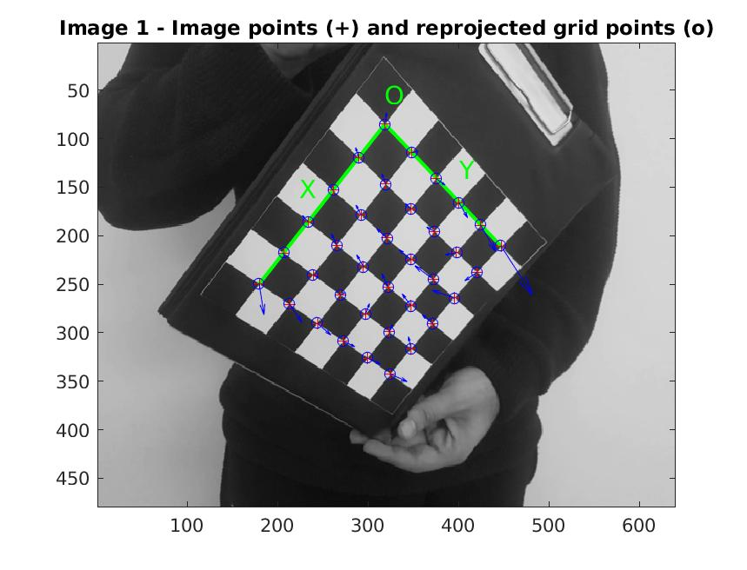

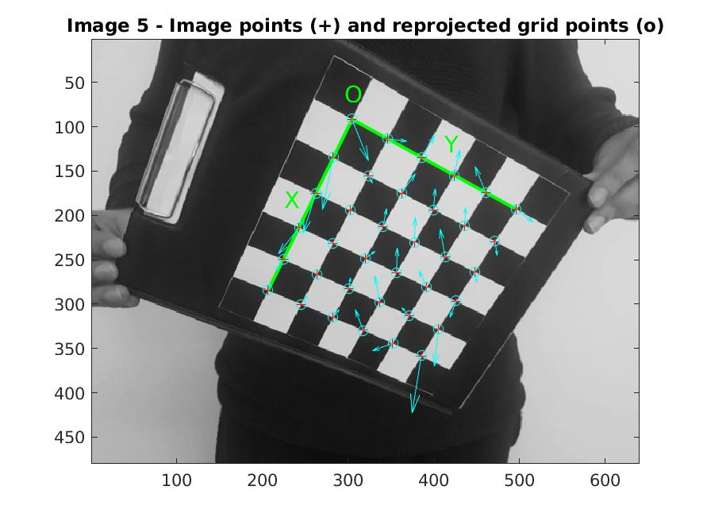
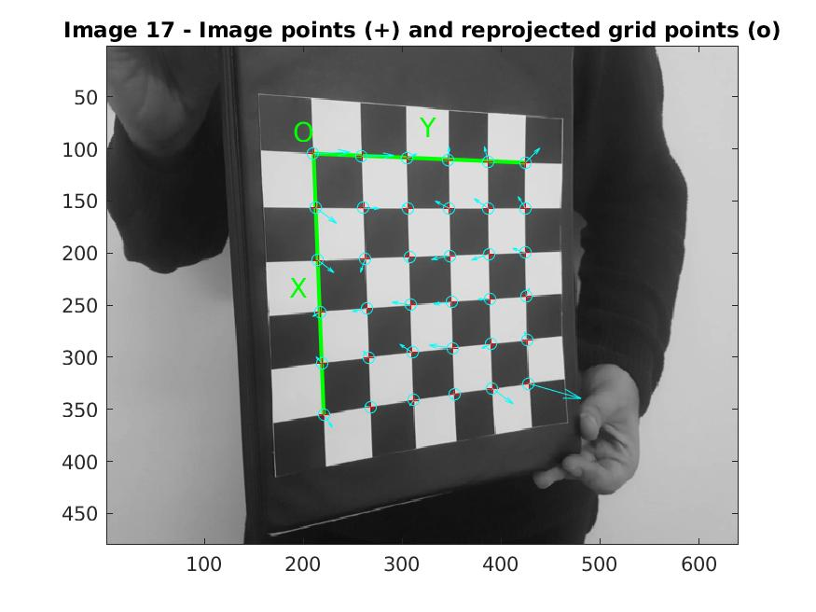

Also, we can see the figures which includes the extrinsic and error rates. As you can see for some image there are significant errors. The error rates in pixels is up to 2.5 pixel which is unacceptable. We need to re calibrate the image and optimize the errors.

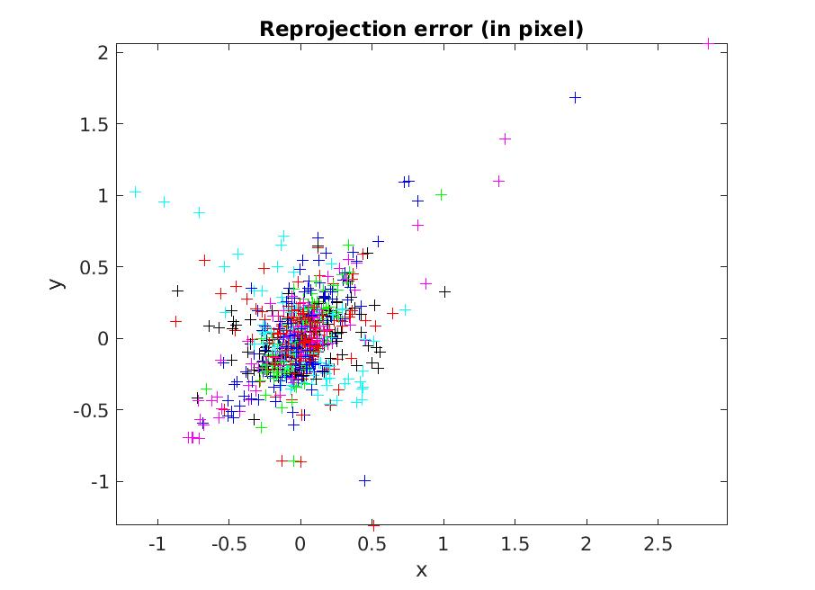

Below you can see the extrinsic parameters figure.

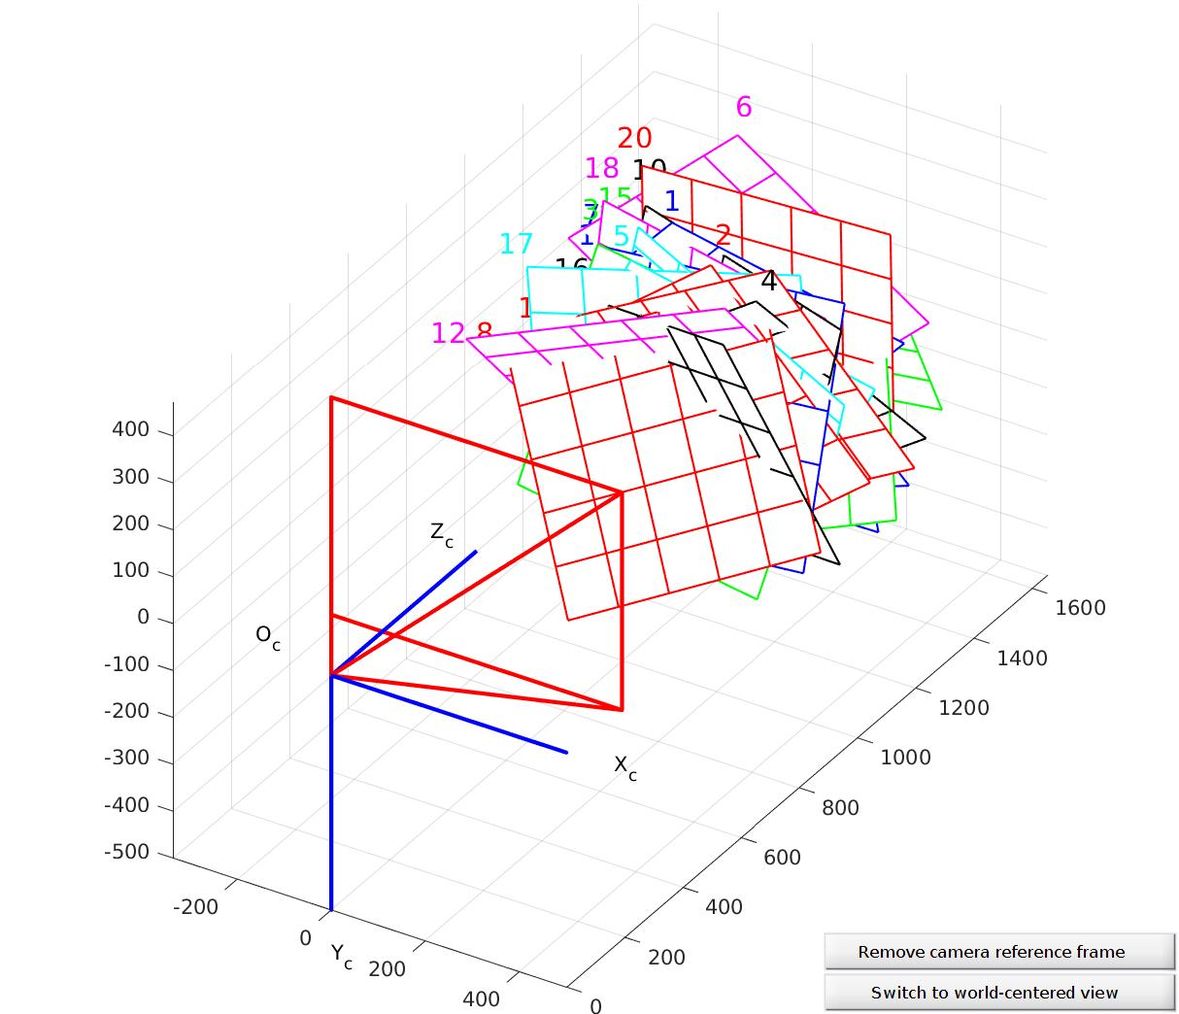
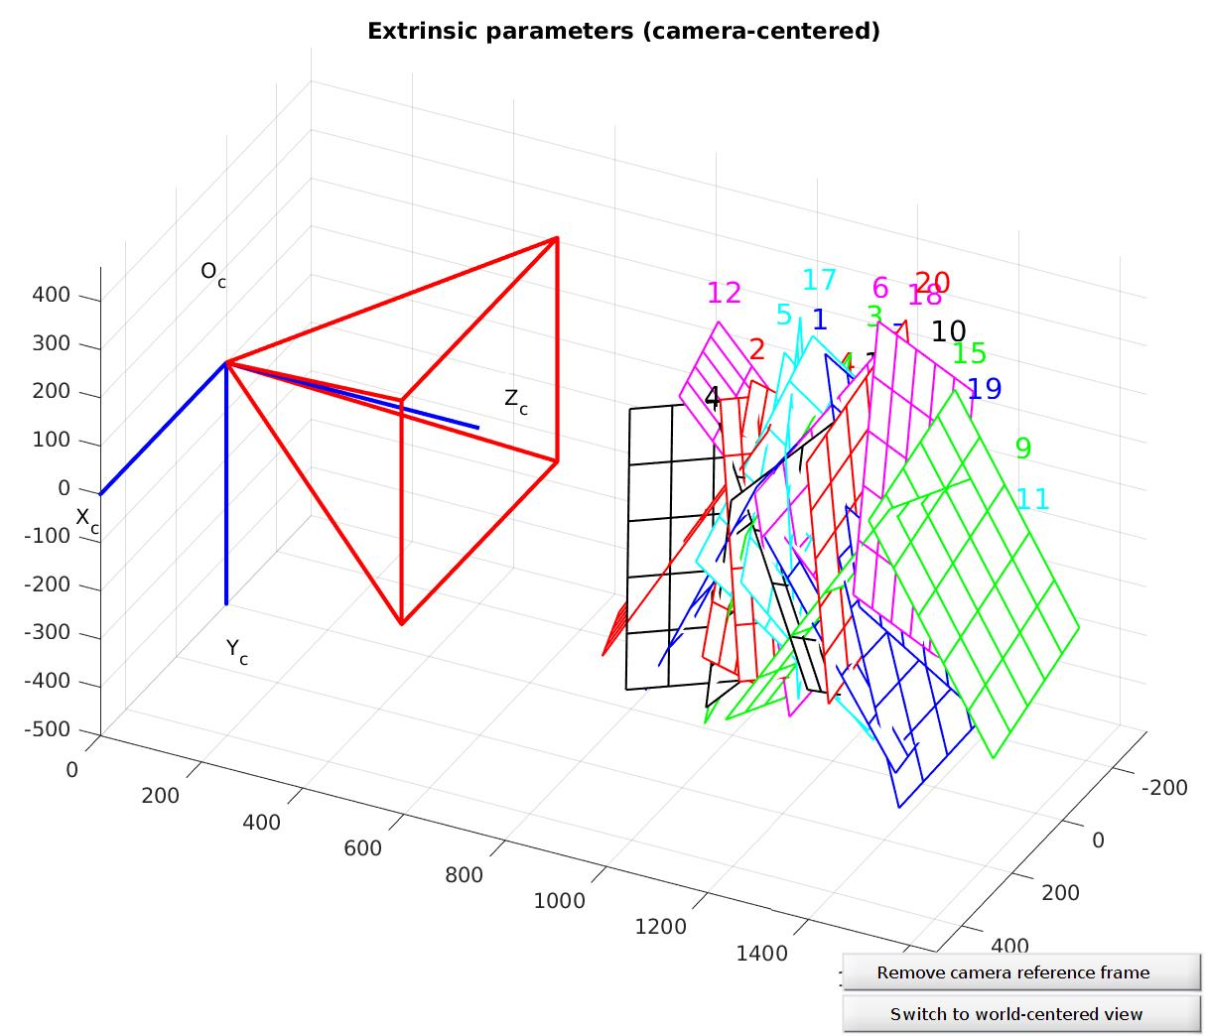

Also, you can find the world-centered extrics in below.

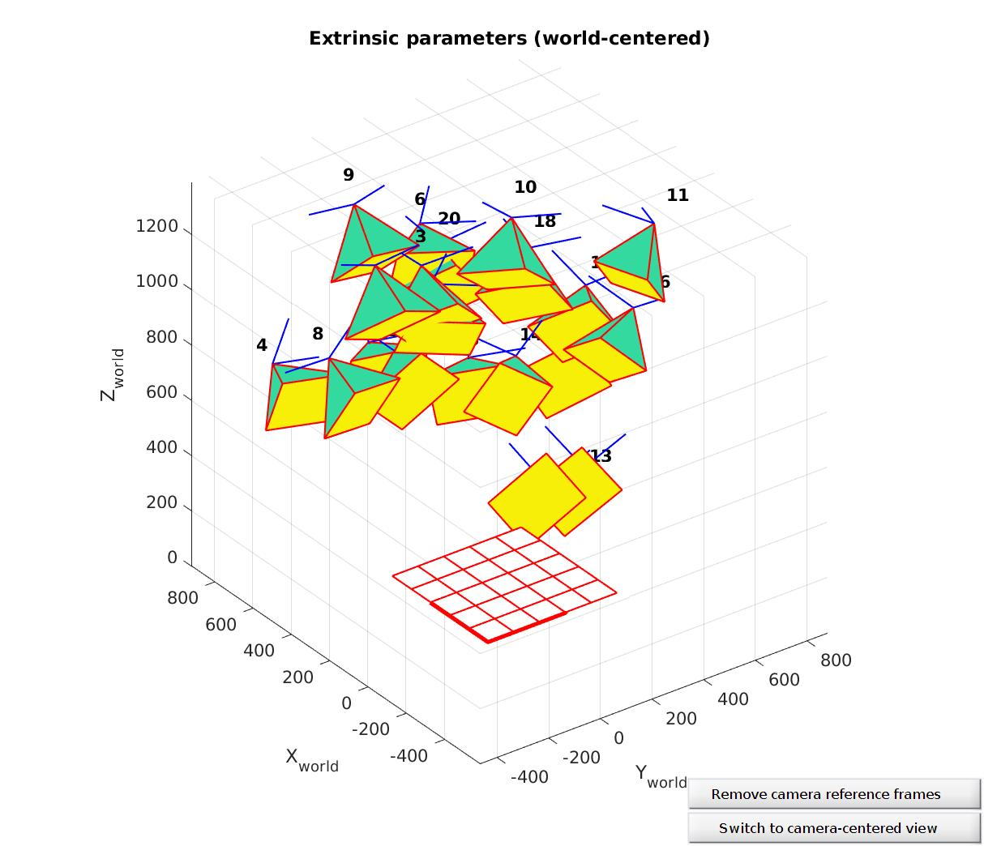
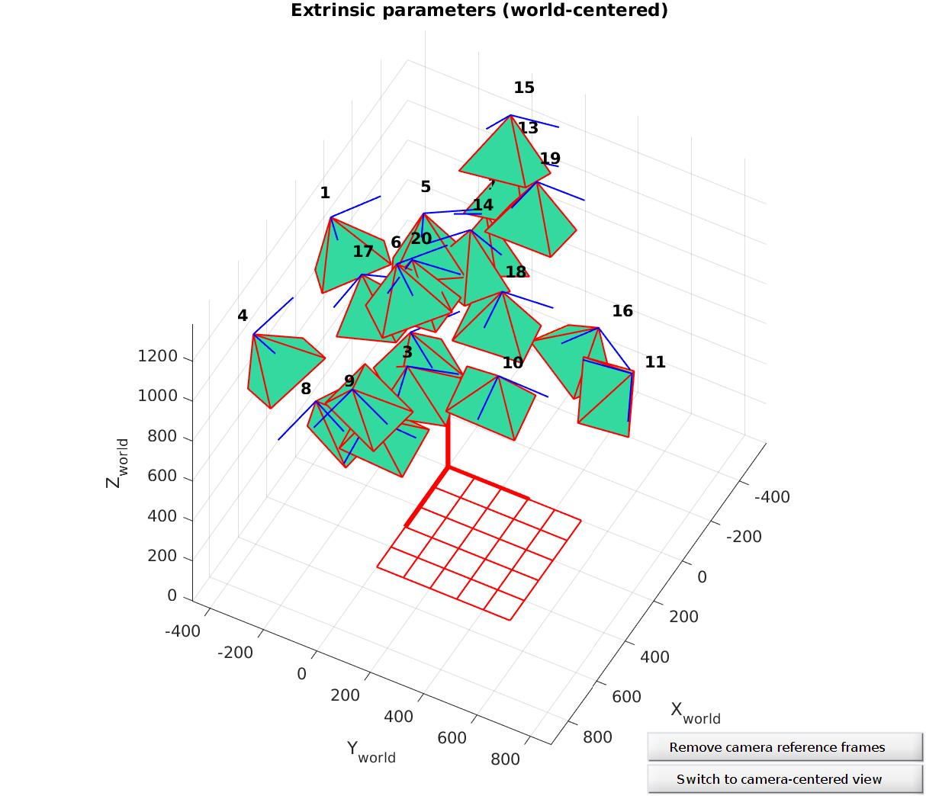

As we already said, the recalibraion process is required to minimize errors. Because notice that re projection error is very large across a large number of figures. To optimize that, we need click on Recomp.Corners. Still, all parameters like wintx winty is assigned by default. After we do the all calibration processes we will analyze the error again to see the optimization.

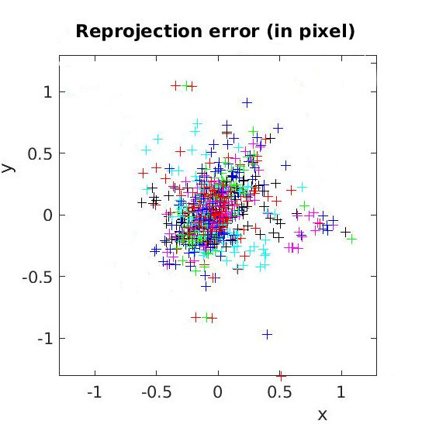

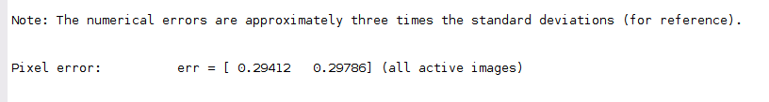

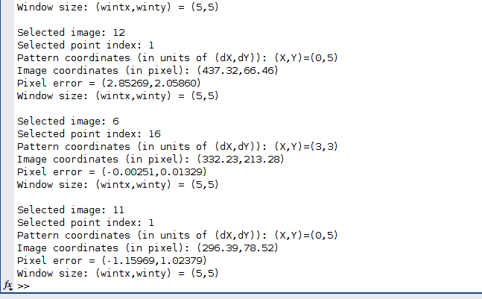
Then we can see the most errorous image by clicking the graph and watch the console.

To deep analysis we also need to look the most incorrect calibrations. In below, there are 2 zoomed-in point to illustrate the figure.
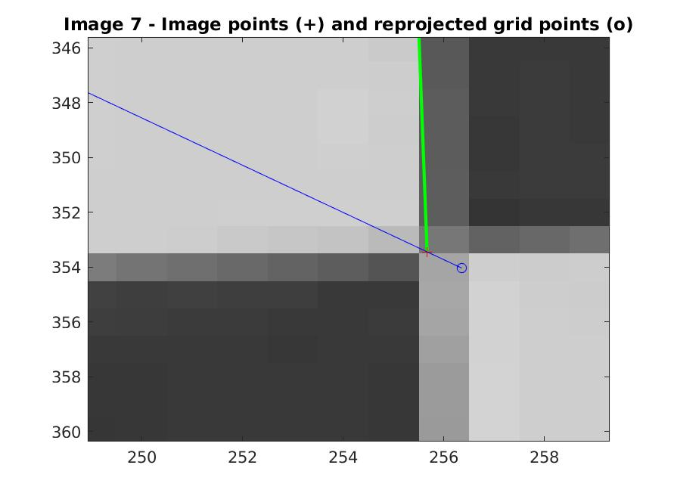
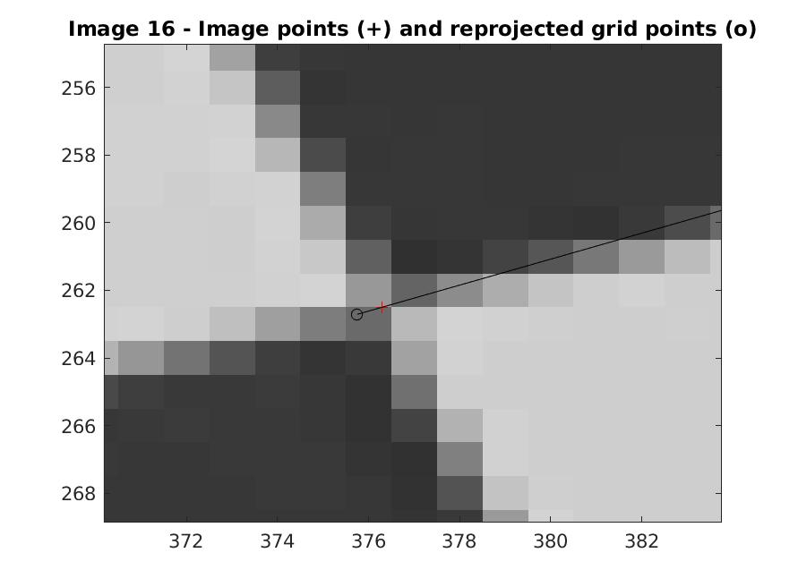

After we satisfied with the result and no more calibration is necessary. The all calibration is done and saved as calib_results.mat. Please notice that the previous calibration saved as calib_result_old.mat which you can find in the attachments. Then we can add 5 image and calibrate again. To see all images please see the mosaic figure below.

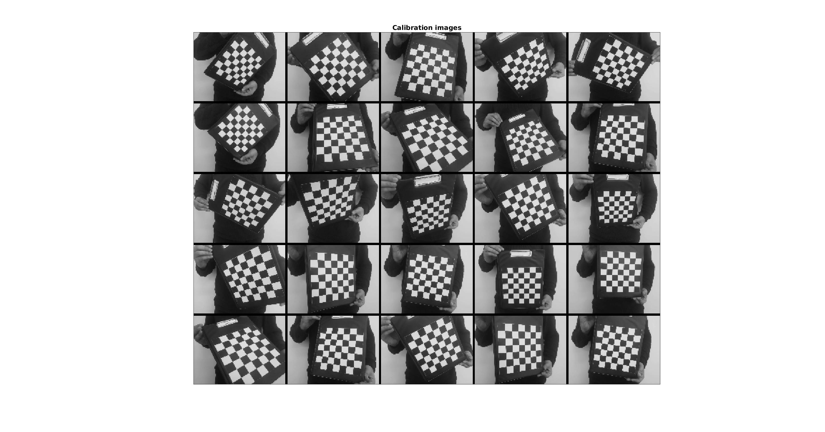

The next task we need to do is make a decision on the appropriate distortion model. To achieve that we need to run visual_distortions.m. Below, you can see the related figures.

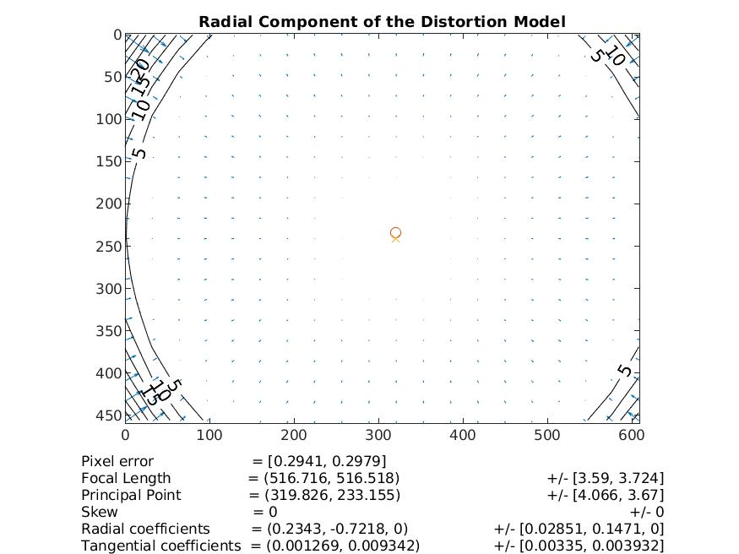

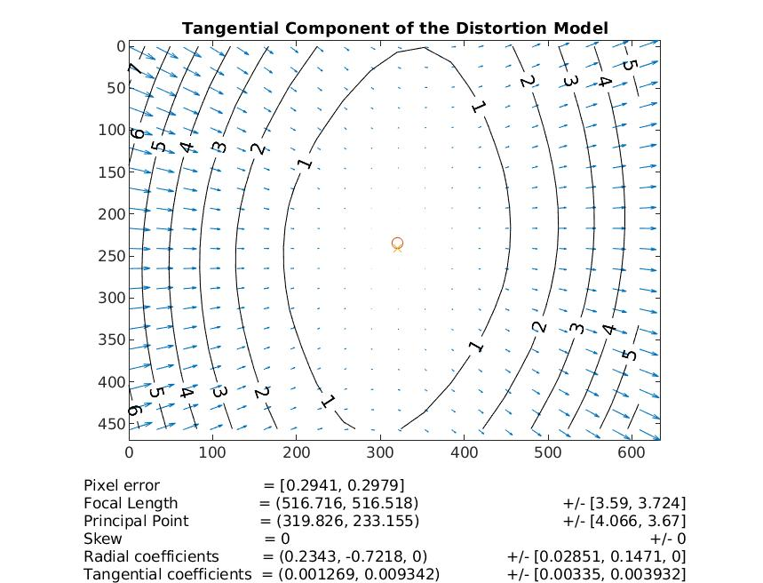
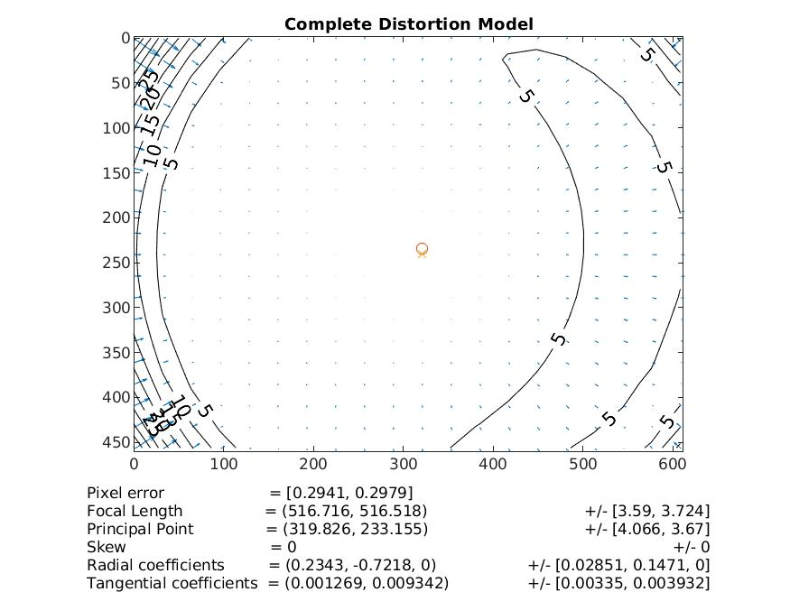

The all calibration process is done by now. Please check the all results in the attachments in detail.

